Graduate Accommodation Booking Process

This is a visual step-by-step guide to what to expect when our bookings process opens. Please keep in mind that we are continually making improvements to our system and there may be some differences in the process between what you see here and what you see at the time of booking. The information given in the screenshots is updated each year and prices, licence terms, available rooms and other details are subject to change.

# Accessing the Accommodation Portal

When we receive the list of graduate offer holders from the College Office, you will receive an invitation to register your interest in College accommodation on our [Accommodation Portal](https://lincolnox.starrezhousing.com/StarRezPortalX). You are not able to register before this time as we won’t have your details! The first time you access our Portal, you will need to select the “verify your credentials” option at the bottom of the page.

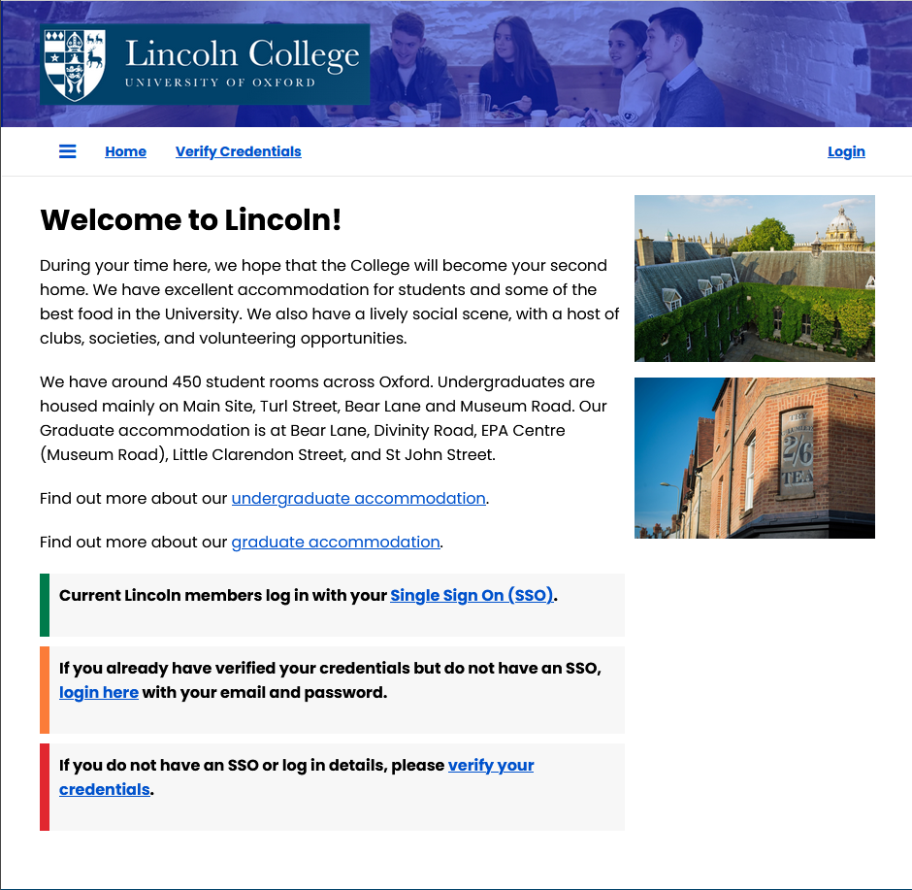

This will take you to the “Verify Credentials” page, where you will need to fill in the email address you used on your University application and your date of birth.

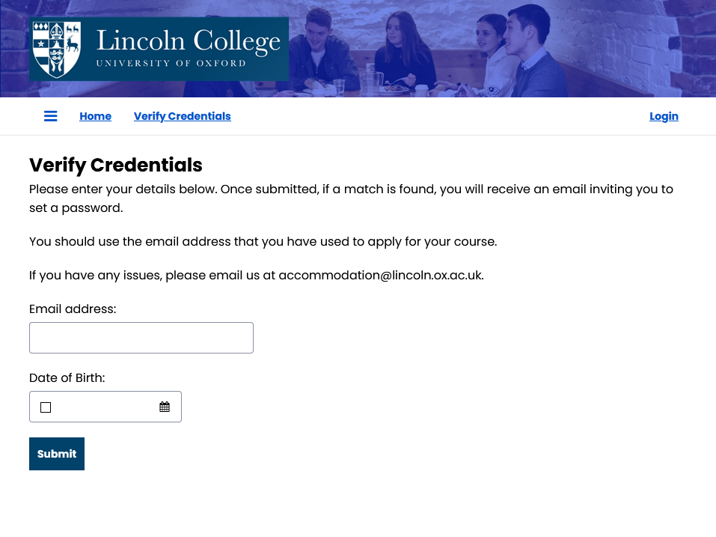

If the details you have provided match the ones we have on record, you will receive an email inviting you to set a password. Please remember to check your junk mail! Check our [FAQs](https://lincoln.ox.ac.uk/wp-content/uploads/Graduate-Accommodation-FAQs.docx) for what to do if you can’t log into the Portal.

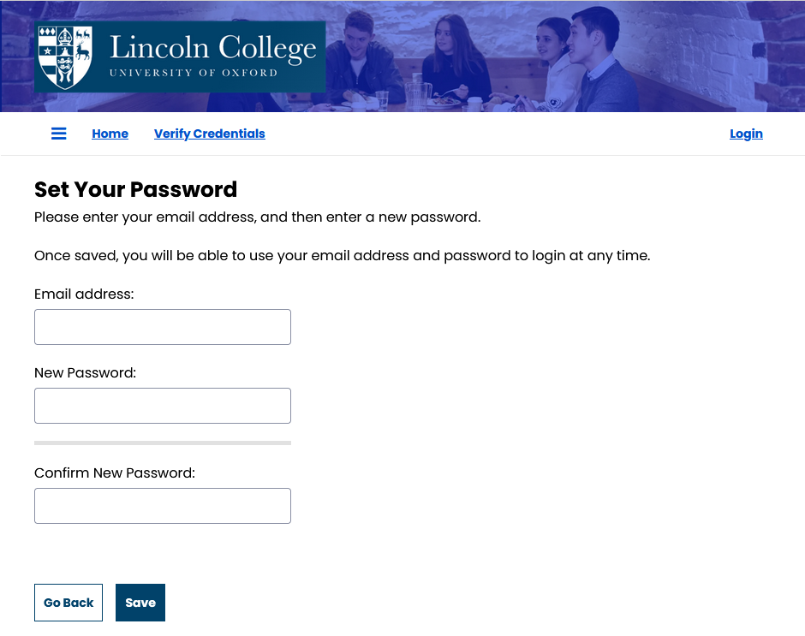

# Application Process

Once you have saved your password, you will be taken to your Home page. To start your accommodation application, select “My Application” at the top, or click the link at the bottom.

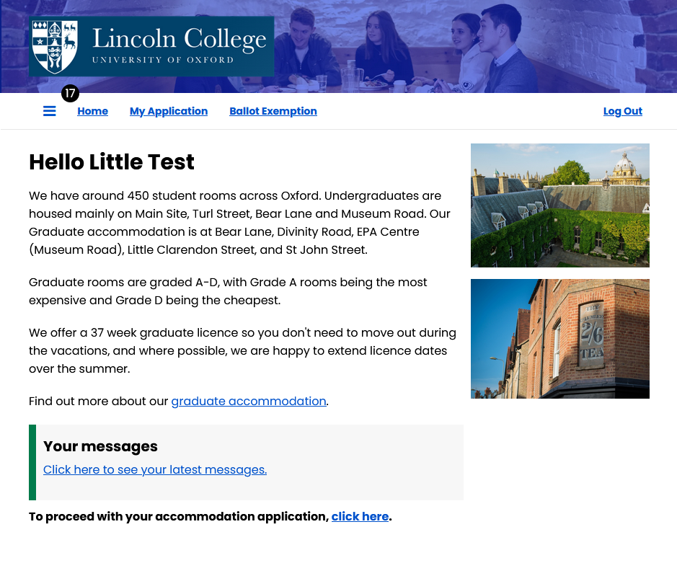

This is the first page of your application journey. You will need to click the “My Application” button to proceed.

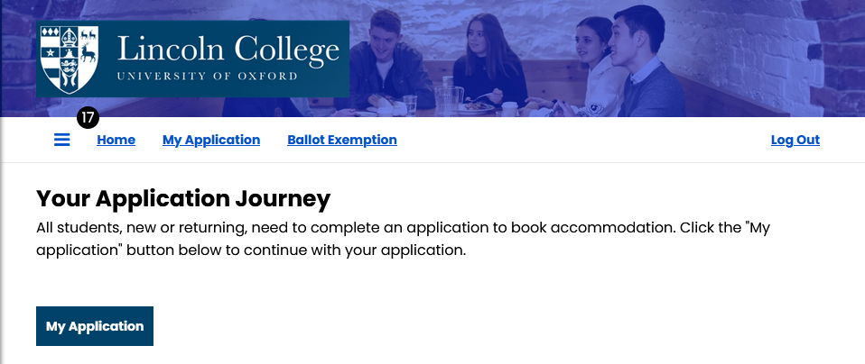

The next page gives some general information about each site (not included here for the sake of brevity!). You will need to click “Continue With My Application” to proceed.

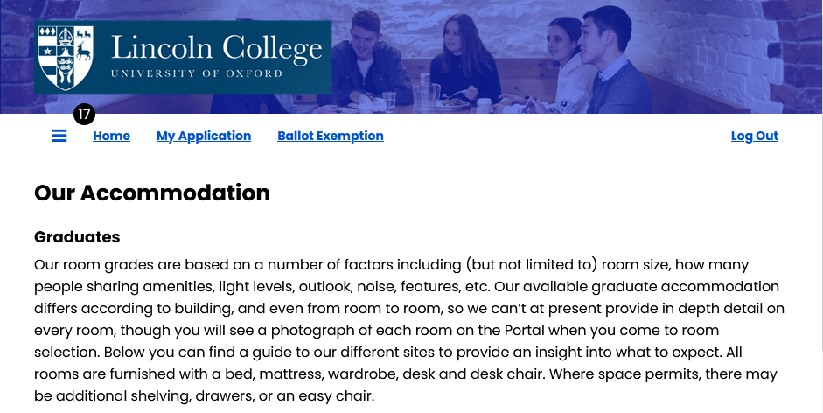

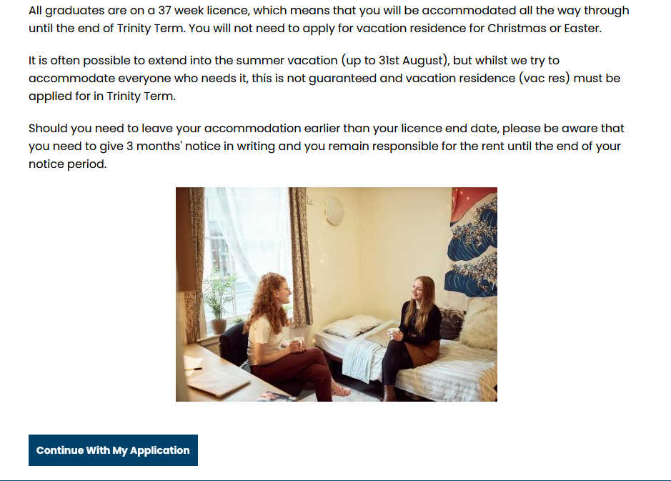

The next page is our Term Selector. We only offer one licence term to Graduates. The dates given on this page will be our standard licence dates for the year you are applying for, and this is what will be reflected on your licence agreement. Please see our [FAQs](https://lincoln.ox.ac.uk/wp-content/uploads/Graduate-Accommodation-FAQs.docx) for early arrivals or extending your licence over the summer.

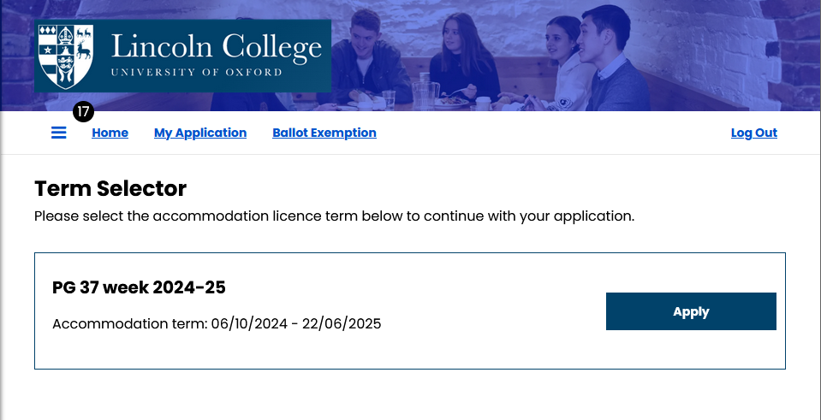

Now you will be asked to confirm your personal details. You will also have the opportunity to find out more information if you have a medical or religious requirement affecting your accommodation. You must advise us at this stage if you require assistance to evacuate in an emergency.

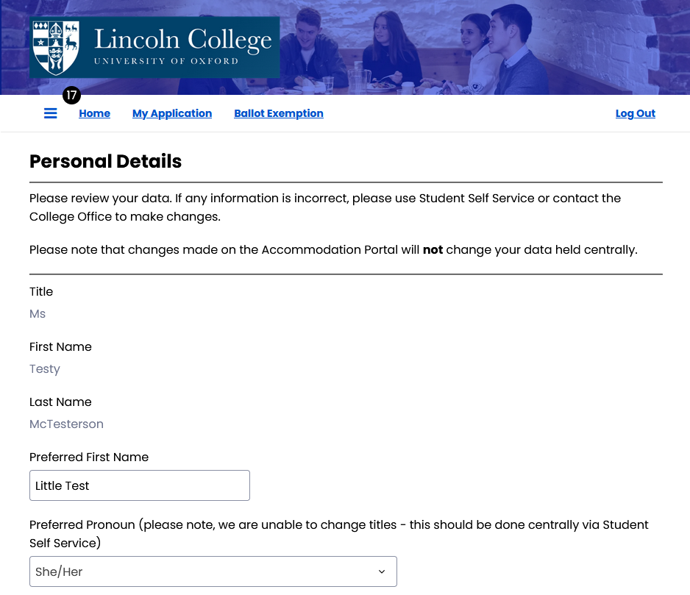

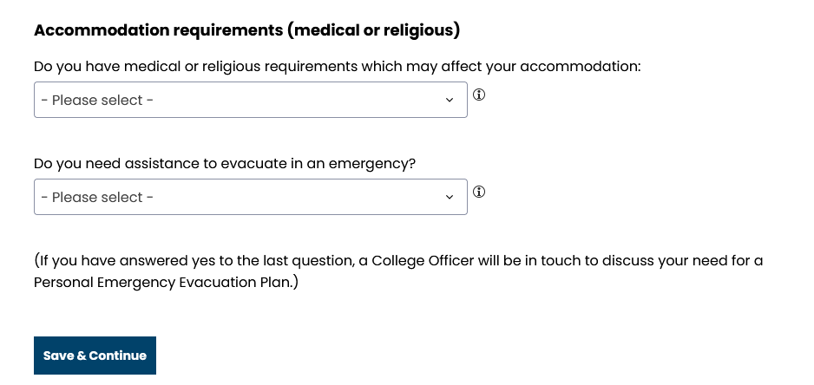

Before bookings open in late June/early July, your application journey will end here.

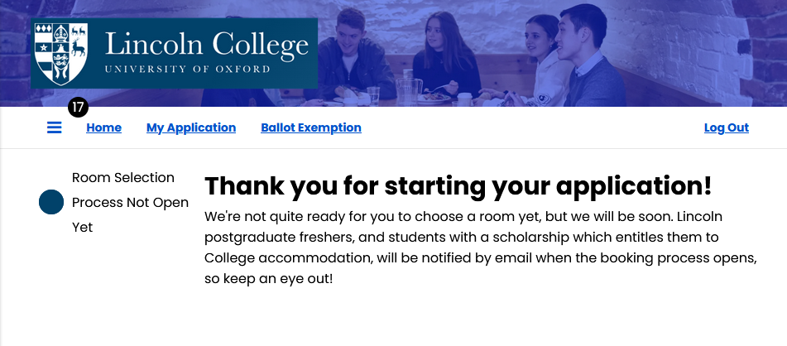

You will be contacted again just before bookings open with a confirmation of what Priority Band you are in (please see [FAQs](https://lincoln.ox.ac.uk/wp-content/uploads/Graduate-Accommodation-FAQs.docx) for further information) and a reminder of the date that bookings open for your band.

Your application for accommodation is not a commitment from you to take a room, nor a commitment from us to provide you with a room. Your application is an expression of interest so that we can keep you informed of the bookings process and assist with any reasonable adjustments as required by law. You are only committed to your accommodation once you have made your accommodation pre-payment and signed your licence agreement.

Read on to find out more about the bookings process!

# Bookings process

Once bookings are open for your Priority Band, log back onto the Portal and select “My Application”. You will be taken back to the “Your Application Journey” page, and the “Our Accommodation” page. When you reach the “Term Selector” page, you will see updated information depending on how far you have got in the process. You will always go through these three pages any time you return to your application.

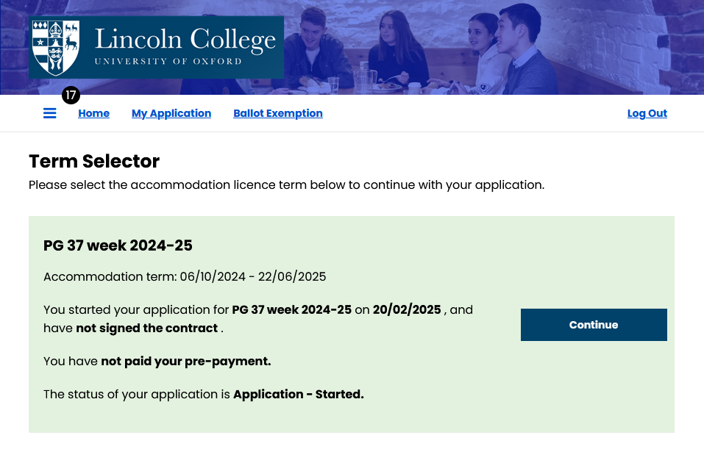

This time, upon clicking “Continue”, you will be taken to our “Room Type Selection” page. If there are no rooms available, you will see the message below.

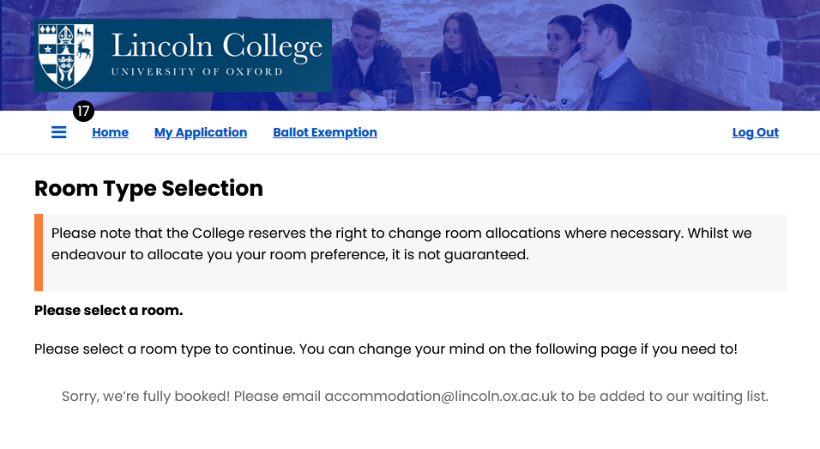

If rooms are available, you will have the opportunity to select your preferred room grade (you can always change your mind and select a different room grade before choosing your room) and view the available rooms. Rooms do get booked very quickly, so it’s best to have a couple of room types or locations in mind before bookings open. We try to give as much information as possible in advance to make this process easier.

Once you have selected your room, you will be taken to a page to view your sample agreement. Then you will need to make your one week pre-payment (please see the [FAQs](https://lincoln.ox.ac.uk/wp-content/uploads/Graduate-Accommodation-FAQs.docx) for further information). Once this has been received, you will be able to proceed to sign your licence agreement.

Please note that this document will be updated over the next few weeks to display the rest of the process with associated screenshots.