

Everything You Ever Wanted to Know About IT at Lincoln…
(…but were hoping someone else would ask)

Welcome to Lincoln. This is a brief introduction to the IT facilities at College; if you have any questions please feel free to get in touch.

Getting Help

The IT Office is staffed by Gerard Fegan (Head of IT) and Pete Good (IT Officer); we are always happy to be your first point of contact if you have a problem of any kind. You can visit us at the top of Staircase 4, email us at it-support@lincoln.ox.ac.uk or even, in extremis, try calling us on 79805. Some problems we can handle in person (virus infections, non-starting laptops, data recovery) but we may have to ask you to take things like major hardware failures to an external repair shop. If you have a department-specific problem, such as a departmental account or software package, it may well be worth contacting the relevant IT people directly. Note: we tend not to prioritise computers without up-to-date anti-virus…

Connecting to the Network

This bit is important: if you want to connect to the network please make sure that you have up-to-date anti-virus software (see below for details on how to access the University free anti-virus software) and are fully patched using Microsoft or Apple software update. You must not connect anything except a computer or consumer/gaming device into the wired network; switches, hubs and any personal wifi transmitting devices are strictly prohibited.

WiFi

There are a number of general-use WiFi networks available: OWL and Eduroam are University-wide while LincolnCollege is a College-specific alternative.

OWL (Oxford Wireless LAN) is restricted to the University and is primarily aimed at visitors whereas Eduroam is a nationwide (and pan-European) network which is available at any University in the UK. You should have had a code allowing you to connect any number of devices to the LincolnCollege network but if you do not have this then you have a couple of options:

Until the end of 0th Week only you can collect an OWL username/password sheet from the Lodge which will allow you access to set up your email and Eduroam accounts if you have not already done so. (Note: you can only connect one device at a time using these temporary OWL credentials so make sure you configure one device completely before reusing these temporary accounts.)

To connect to Eduroam:

- Connect to a wireless network - if you use OWL you can ignore the login prompts.
- Go to https://register.it.ox.ac.uk and log in using your SSO/Nexus credentials.
- Click on the Self-Registration link on the left side of the page.
- Click on Register for a Remote Access Account and set a password. Note the time at which the account will become active.
- Once the Remote Access account has activated go to https://cat.eduroam.org/
- Click on the download link at the bottom of the page and select University of Oxford as your home institution.
- Download and run the appropriate installer.
- For iPhones you will need to go to the Installed Profiles area of Settings and install the downloaded Eduroam profile.
- Connect to the Eduroam network and enter your username in the form linc1234@OX.AC.UK (note the uppercase). Enter the Remote Access password and you will be able to connect to Eduroam. This connection will work throughout Oxford.

If you have an Android phone you will find it easier to download the installer from the Play Store – just search for Eduroam. NB you may need to go to the Eduroam network settings and switch off Limit IP Address Tracking before the network will connect.

VPN

If you are connected to another network, in a public area or at home for example, you can still access all of your usual Oxford facilities by using the downloadable VPN client.

1. Go to https://register.ox.ac.uk and log in using your SSO/Nexus credentials.
2. Click on the Software link on the left side of the page
3. Click on the appropriate download link and run the appropriate installer.

Once the VPN software is installed you need to connect to vpn.ox.ac.uk and use your SSO password to connect.

If you have a non-secure device such as a Playstation, Alexa or similar then this will not work with Eduroam but will work if you connect it to the LincolnCollege wifi network using your personal code. Please note: Because of the nature of these consumer devices anyone else connecting to this shared network will be able to see and potentially access them. If you connect a device to this network you are responsible for your own security. If your Alexa starts playing someone else’s music you only have yourself to blame…

Use of any IT facilities at Lincoln implies acceptance of the University and College rules and acceptable use policies. See https://governance.admin.ox.ac.uk/legislation/it-regulations-1-of-2002 for details. The network may be monitored to maintain compliance with these regulations.

IT Rooms and Printing

JCR/MCR IT Rooms

There are College IT rooms located in Lincoln House for undergrads and in Bear Lane and the EPA Centre (on SC28) for graduates. Each has a general-purpose PC along with printers. Your username for this system will be the same as your SSO but the password will be different. You should have been emailed with details of this local account; if you have not received this email (or have forgotten the details) please email the IT Office and we will happily reset/create one for you. Please note that food and drinks are not permitted in the IT rooms: seriously, who wants to try and work surrounded by someone else's old burger boxes and stale coffee? Please don't install software on these PCs.

Printing

As well as the black and white printers in the IT rooms there is also a printer in the Mitre, one in the Little Clarendon St building, and colour printer/scanners in the Library and Bear Lane Reading Room basements. An A4 page costs 5p per sheet in black and white, a colour page is 20p. A3 pages are double the A4 prices. For undergraduates College will underwrite the first £50 of printing costs; for graduates this will be the first £100 - anything in excess of these figures will be added to battels at the end of the year. You are responsible for keeping an eye on your printing totals; a figure on the web interface page will let you check how many pages you have printed. Paper for the printers may be collected from the College Office or Porters’ Lodge when supplies get low. Please remember to sanitize before and after using any shared equipment.

You can print directly to any of these printers from anywhere with a network connection. Rather than connecting to a printer directly; just point a web browser at https://lincprinting.linc.ox.ac.uk:9192 and login using your Lincoln username and password.

Email and Phones

Email

You will automatically be allocated the standard University firstname.lastname@lincoln.ox.ac.uk email address above (this format is the same for everyone at Oxford but if there is a problem with the address above please give us a call) and a Single Sign-on account (generally called an SSO) which will allow you access to most University IT services. You may also have an email address in the form firstname.lastname@department.ox.ac.uk; if you do have two email addresses don’t worry, email sent to either address will go to the same inbox. You should already have full instructions on activating your account; please see one of us if not. Make sure you have set up a security question which will allow you to reset your password should you forget it! You can access your email using a web interface via https://outlook.office.com or connect via a client email program such as Outlook, Thunderbird etc. or a mobile device (for configuration details see https://help.it.ox.ac.uk/nexus365). You can tweak your preferred email settings from the web interface or via https://register.ox.ac.uk. You should receive regular news updates throughout term from either the JCR or MCR via their mailing lists; if you haven’t seen anything after a couple of days please check with the IT Office that you are properly subscribed.

MFA

Access to email, and other University services, is protected by multi-factor authentication. We strongly suggest that you set up a secondary MFA method in case your primary device is lost or damaged. A secondary phone number or another Authenticator are both good options. If you do lose your only MFA device we can reset your account if necessary of course.

IT Safety and Security

Anti-Virus Software

As mentioned before, you may not connect a computer to the network unless you have up-to-date anti-virus software. (If you currently have none, I will make an exception if you are connecting specifically to install or update some!) There is no rule dictating which AV software you use: just make sure you have something… If your current AV is out-of-date or has reached the end of its licence then the University offers Sophos Anti-Virus entirely free for all students. To take advantage of this visit https://register.it.ox.ac.uk/self/software (you will need to log on using your usual SSO userid) and download the appropriate client. Obviously, game consoles and personal assistants cannot run AV software which is why we have the alternative, firewalled, network to protect everyone else.

Operating System Patches

Please make sure your OS, whether a PC, Mac or tablet/phone, is set to download the latest security updates. Many of the latest Trojan attacks are aimed at unpatched systems.

Phishing

Phishing emails are a perennial problem but are particularly common at this time of year and do sometimes catch out the unwary. The most common type will typically be trying to obtain personal information such as usernames and/or passwords or financial information such as banking details. Luckily, there are some obvious ways to spot these emails…

This is a fake email aimed at obtaining your SSO user details by claiming that you need to log in and ‘verify’ your account:

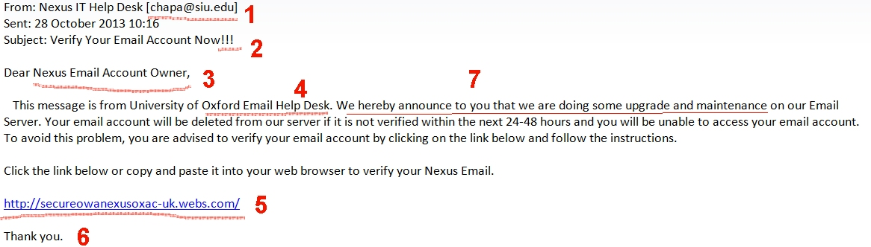

Things to note:

- Not sent from an Oxford email address
- Genuine emails seldom use such strong emphasis!!!
- Not addressed to you personally. No indication that the sender knows your SSO/userid
- Very vague details about sender
- Not an Oxford link
- In this example there is no sig file giving an address which could be used to check the validity of the email. Other emails may have totally false information here.
- Poor English. Other emails may have spelling mistakes or blatant grammatical errors.

A genuine email from IT Services will look like this:

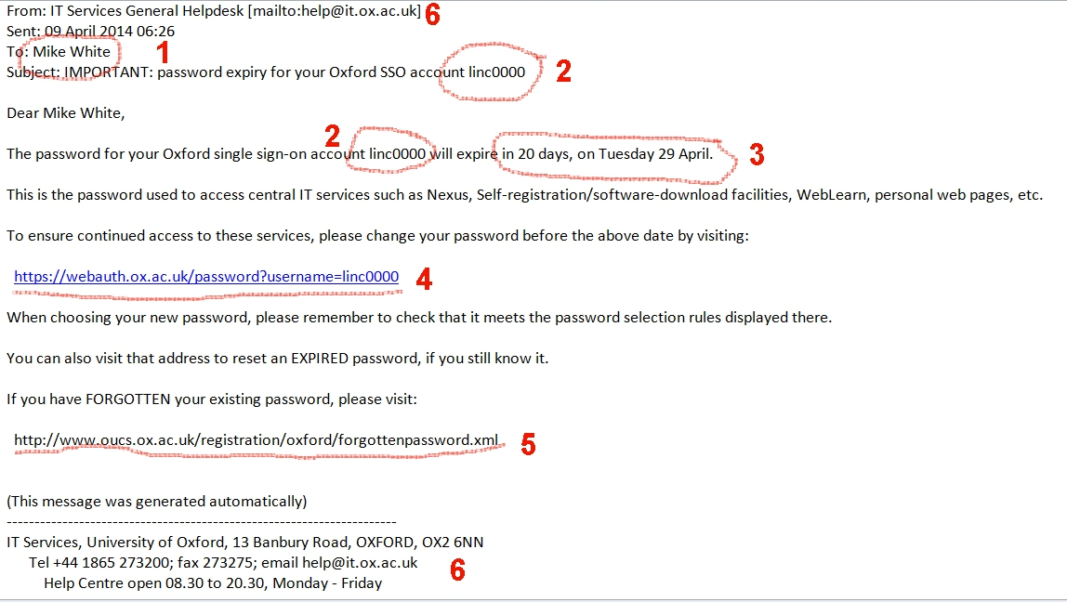

Things to note:

- Personally addressed
- The sender knows my SSO userid in advance
- Specific details I may know or can check
- Genuine Oxford link, again personalised with SSO information – the https is an added security check. Note: You may need to hover over the link to verify that it actually points where it claims!
- Link to instructions on how to reset a forgotten password, NOT a request to email a password back to the sender
- Lots of ways to contact the sender to check if the email is genuine

Common Sense

To reiterate the point above: no reputable email will ever ask you to send your username and password. As a rule of thumb, any email addressed to ‘Dear Student’ or ‘Dear User’ can be safely ignored. If an unsolicited email comes in asking you to click an embedded link please don’t! Similarly, anyone opening an attached document or (especially) program frankly deserves all they get. Other scams purport to come from Paypal, Facebook, a bank, the Tax Office etc. Just consider whether your bank would ever email you as ‘Dear User’ and ask for your login details before you hit reply… We are happy to help if you want to check on the validity of any potentially dodgy emails you may receive – just forward it on to it-support@lincoln.ox.ac.uk and we will take a look for you.

Whoops

If you do get caught out don’t panic. By all means get in touch with the IT Office as soon as possible; generally, you will need to change your passwords and/or run an anti-virus scan but a fast response is the best defence.

Miscellaneous bits and pieces

University IT Services

The University offers a wide range of IT services to students including:
- Free software (including Microsoft Office) – https://www.office.com
- Training courses - http://courses.it.ox.ac.uk/
- Lecture podcasts - https://help.it.ox.ac.uk/podcasting-and-media-publishing … and far more.

For information on what other services are available try starting at: http://www.it.ox.ac.uk/want/get-started which should answer most of your initial questions.
You could also visit: http://help.it.ox.ac.uk or http://www.it.ox.ac.uk

IT Rules

Note that use of any IT facilities at Lincoln implies acceptance of the University and College rules and acceptable use policies: see https://governance.admin.ox.ac.uk/legislation/it-regulations-1-of-2002 for details. The network is regularly monitored to maintain compliance with these regulations. Any user who does not have up-to-date anti-virus software installed and who does not have their computer software suitably patched with critical updates to prevent viruses/worms may be disconnected at any time. Please remember that one user with a virus can cause problems for everyone on the system.

Water, water everywhere… A special note.

Every year we get at least one case of a laptop which has been soaked with water, either via a spilled glass or through being left beside an open window. That being the case it is worth noting the steps to take should this happen to you:
- Shut down the device immediately
- Unplug the device and, if possible, eject the battery
- Wipe off any excess water.
- Stand the device on its side somewhere warm for a minimum of THREE days.
- After the three days try to switch on the device. If it fails to start call the IT Office.

Accounts

You do have a confusing number of accounts to manage so in summary:

Account | Used for
SSO (linc1234@ox.ac.uk) | Email, Sharepoint, all University services
Eduroam (linc1234@OX.AC.UK) | Eduroam wifi
Lincoln local account (linc1234) | Website access, printing

And finally… green issues

The University uses enough power as it is so if you aren’t using your computer overnight then please switch it off. Similarly, please try to keep printing down to a minimum. If you have used print cartridges from your own printer and don’t want to recycle them yourself then the IT Office will be happy to do it for you.

Don’t forget, if you have any problems or questions we are here to help.

Pete and Gerard

it-support@lincoln.ox.ac.uk

